Leaf Taphonomy, Surface Preservation and Fluorescence:

An analysis of Betula leaf buried in clay
Alexis Fornallaz
19th October 2026
Table of Contents
1 Introduction 2
2 Filters and imaging channels 2
3 Response variables 3
4 Statistical approach 4
5 Data 4
6 Composite images 4
7 Surface change 5
8 Fluorescence change 6
8.1 Filter 535–607 nm, excitation 405 nm 6
8.2 Filter 620–680 nm, excitation 405 nm 6
8.3 Filter 689–749 nm, excitation 405 nm 6
9 Fluorescence ratio Filter 620–680 / Filter 689–749 nm 8
10 Reflectance change 9
10.1 Filter 457–487 nm, excitation 470 nm 9
10.2 Filter 500–530 nm, excitation 525 nm 9
10.3 Filter 620–680 nm, excitation 635 nm 9
11 Summary of all models 11
12 Spectra 11
12.1 Raw radiance 12
12.2 Normalised to the area under the curve (AUC) 12
12.3 Normalised by integration time 13

1 Introduction
This analysis tests how burial affects leaf surface area and multispectral imaging signals in Betula leaves buried in clay for several durations. Each leaf is imaged before burial and again after recovery, so every response is expressed relative to the baseline of that same leaf (paired design). Leaf spectra were also acquired with a JETI spectrophotometer.
The main questions are:
- How do leaf surface and the imaging signals (fluorescence and reflectance) change during burial?
- Are the spectra coherent with the multispectral imaging?

2 Filters and imaging channels
The images are acquired through five filters, identified here only by their wavelength window (below). The windows overlap, and each imaging channel pairs one filter window with one illumination wavelength (the x in the channel name). When the illumination lies inside the filter window the channel records reflected light; when it lies at a shorter wavelength than the window, the channel can only record fluorescence.
Filter windows. The spectra are shown between 625 and 850 nm.
Filter | Width (nm) | Inside spectra window
F 457–487 nm | 30 | no
F 500–530 nm | 30 | no
F 535–607 nm | 72 | no
F 620–680 nm | 60 | yes
F 689–749 nm | 60 | yes

Imaging channels (filter window and illumination wavelength).
Filter | Illumination (nm) | Signal
F 457–487 nm | 470 | reflectance
F 500–530 nm | 525 | reflectance
F 620–680 nm | 635 | reflectance
F 535–607 nm | 405 | fluorescence
F 620–680 nm | 405 | fluorescence
F 689–749 nm | 405 | fluorescence
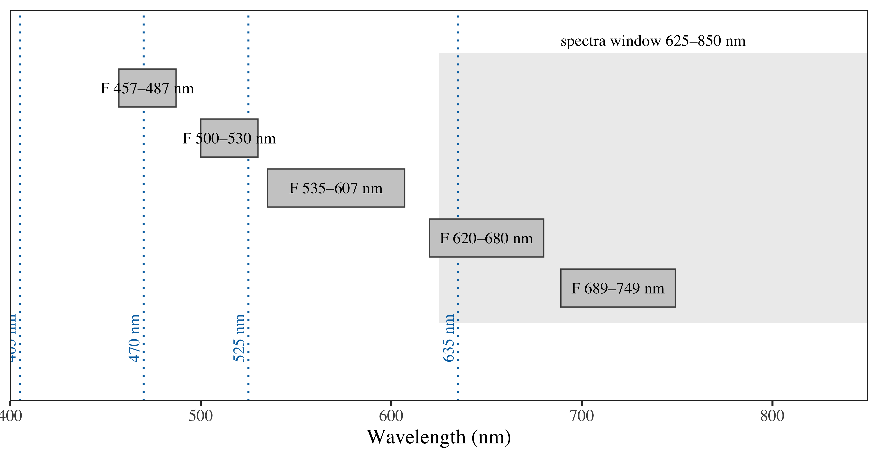
Figure 1: Filter windows (grey bars) and illumination wavelengths of the imaging channels (dotted lines). The shaded band is the wavelength range of the spectra figures.

3 Response variables
Surface: Percentage change relative to the initial area (0 = no change, -20 = 20 % loss, +20 = 20 % gain):
$$\%ΔSurface=100×\frac{Surface_{final}-Surface_{initial}}{Surface_{initial}}$$
Imaging channels: Log₂ ratio of the final to the initial signal (0 = no change, -1 = halved, +1 = doubled). The log₂ ratio is used because it gives a better-behaved distribution than the raw ratio:
$$\log_{2}(R)=\log_{2}\left(\frac{Signal_{final}}{Signal_{initial}}\right)$$
F 590–710 / F 659–779 nm ratio. Change in the relative response of the two fluorescence channels (x405), to be compared with the spectra (positive = the F 620-680 nm channel increased relative to the F 689-749 nm one):
$$\log_{2}\left(\frac{F_{620\text{–}680,final}/F_{689\text{–}749,final}}{F_{620\text{–}680,initial}/F_{689\text{–}749,initial}}\right)$$

4 Statistical approach
Each response is fitted with two additive models without interactions, a simple linear regression and a polynomial of degree 2:
- Linear response ~ time
- Polynomial (degree 2) response ~ time + I(time^2)
Effects are tested with a sequential (Type I) ANOVA at $α$ = 0.05, and the text gives the verdict, F, p, R², AIC and the number of leaves n for each model (with the slope of burial time, change per day, for the linear model) (with the curvature for the polynomial model).
The two models are then compared: the polynomial is retained as the best model only if its quadratic term significantly improves the fit (nested F-test, $α$ = 0.05) and lowers the AIC; otherwise, the simpler linear model is kept. In the figures, each curve (one per substrate) is fitted separately, and its p-value (overall F-test) and adjusted R² are written on the panel.

5 Data
After removing the problematic samples (in this case only 1), the dataset contains 25 paired measurements, buried for 0, 4, 7, 11, 14, 21, 28, 35, 42, 49, 56, 63, 70 days.

6 Composite images
Composite images generated by Leaf_decomposition_pipeline.ipynb. Illumination and scale are identical across the set and the leaves are rotated. Only samples on the spectral plot are shown for the sake of brevity.
Figure 2: These are the composite images for the fluorescence of each leaf after n days.
Figure 3: These are the composite images for the reflectance of each leaf after n days.

7 Surface change
- Linear: burial time: significant decrease (F(1, 23) = 12.47, p = 0.002; slope = −0.186 per day); whole model: F(1, 23) = 12.47, p = 0.002; R² = 0.35 (adj. R² = 0.32); AIC = 165.3; n = 25.
- Polynomial (degree 2): burial time: significant (F(1, 22) = 12.06, p = 0.002); burial time²: not significant (F(1, 22) = 0.25, p = 0.621); whole model: F(2, 22) = 6.16, p = 0.008; R² = 0.36 (adj. R² = 0.30); AIC = 167.0; n = 25.
- Best model: linear. The quadratic term does not significantly improve the fit (nested F(1, 22) = 0.25, p = 0.621); linear vs polynomial: AIC 165.3 vs 167.0, adj. R² 0.32 vs 0.30.
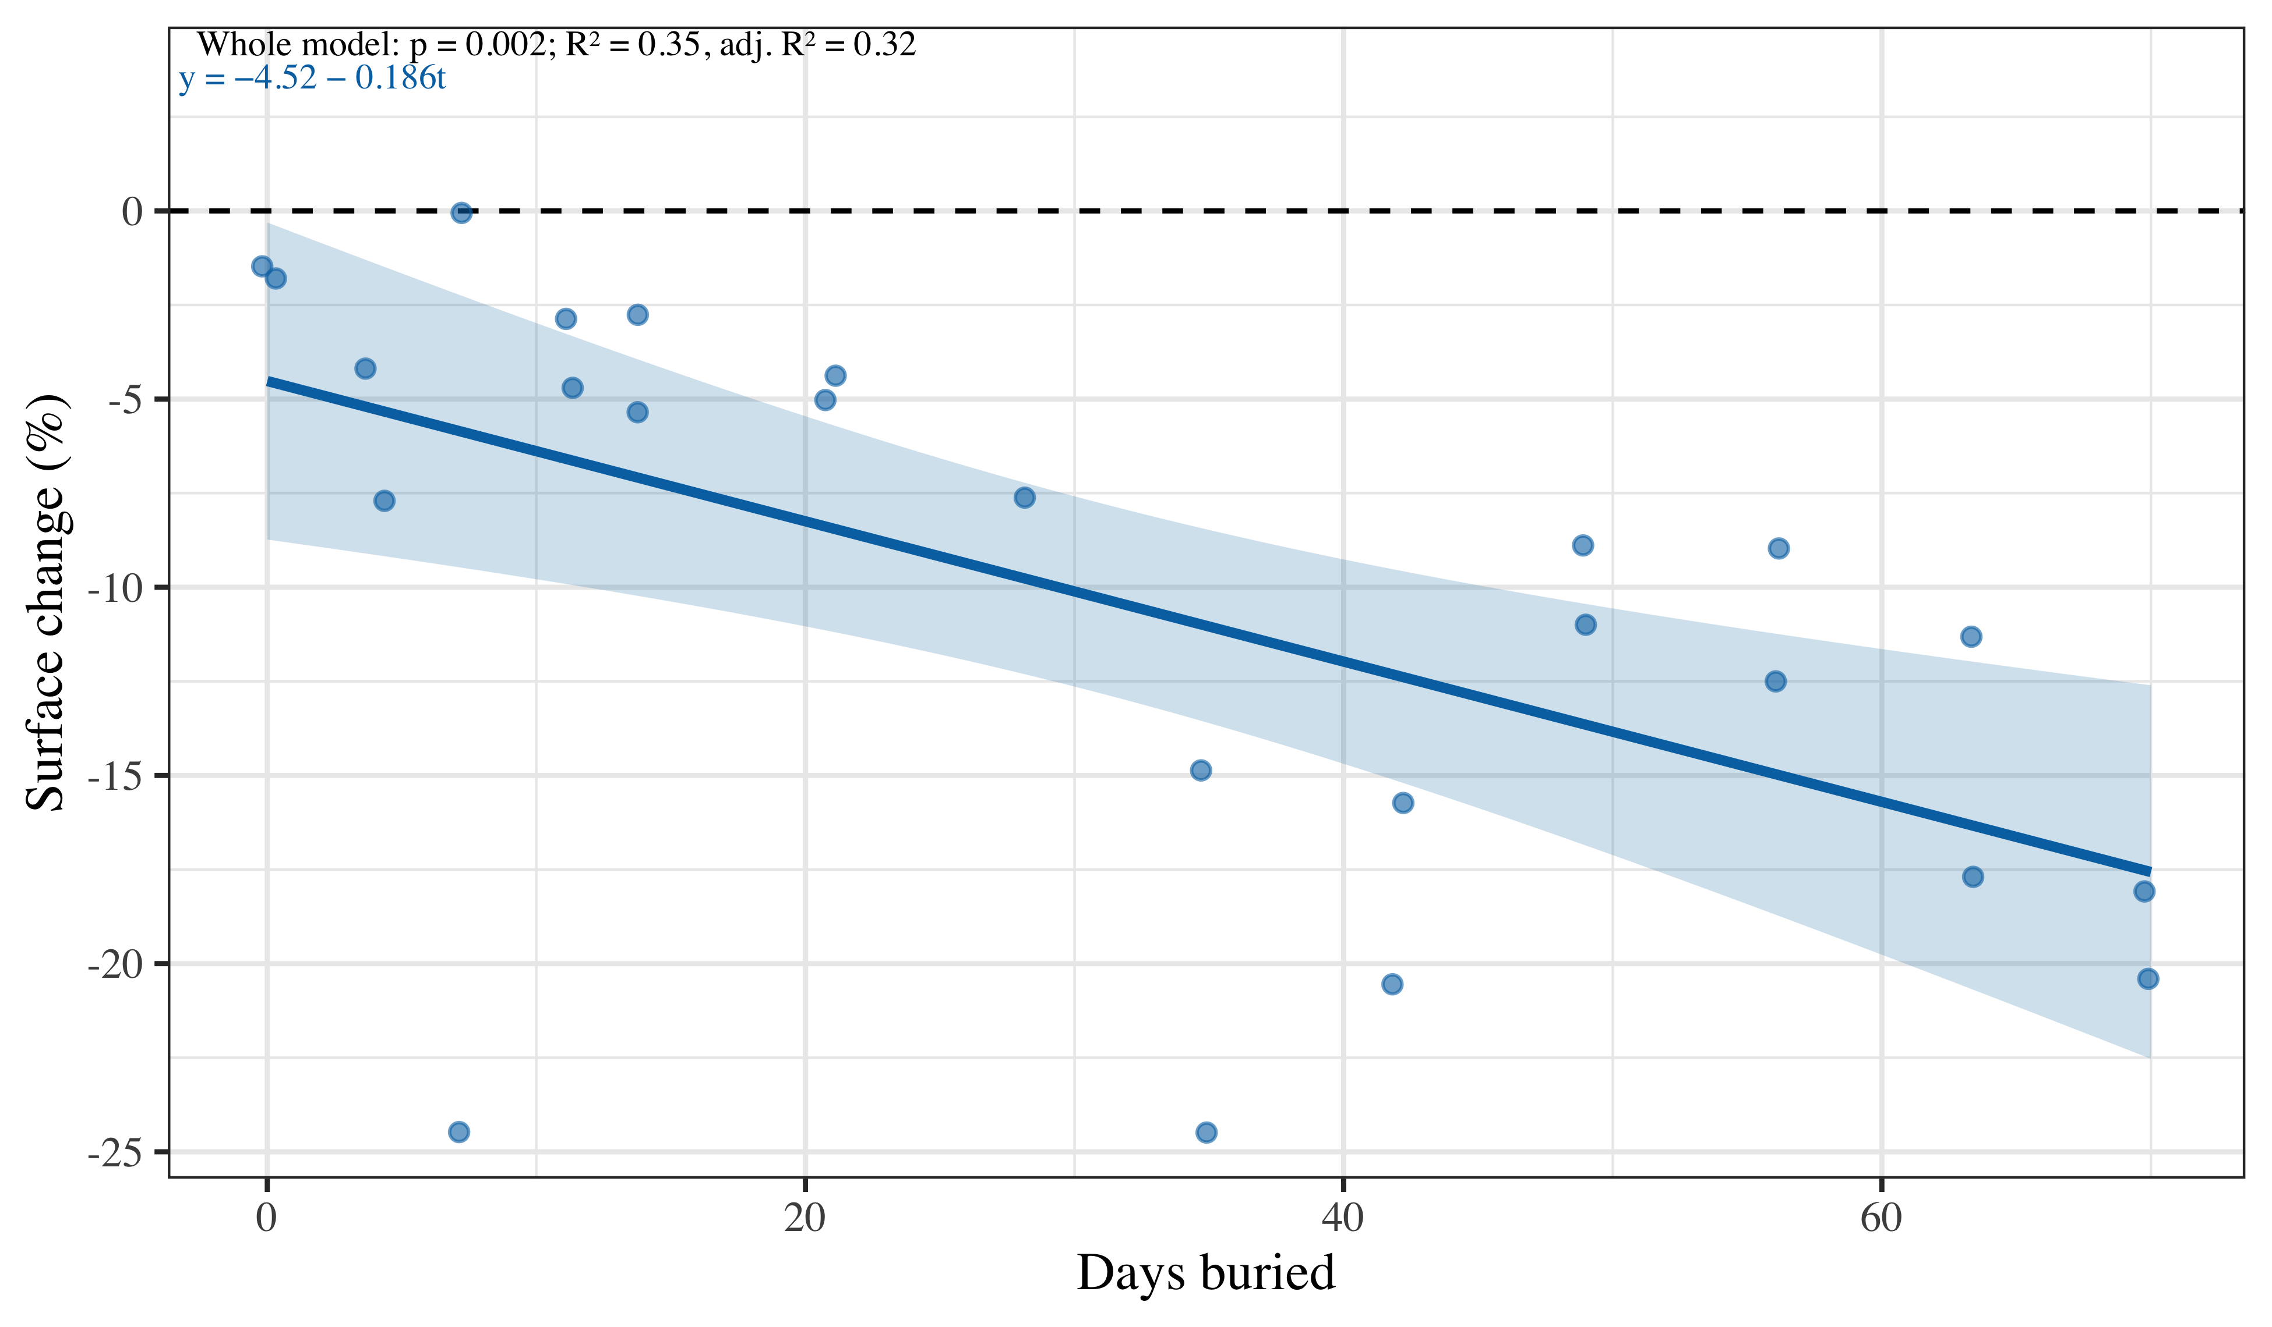
Figure 4: This figure depicts the significant relationship (p = 0.002) of the surface change in percent relative to the leaf initial surface and the number of days that the leaf spent buried. On average for each additional day buried the leaf loses 0.186% of its initial surface (see the blue trend).

8 Fluorescence change
Response: log₂(final state/ initial state) for each fluorescence channel (illumination at 405 nm); positive values = increase.

8.1 Filter 535–607 nm, excitation 405 nm
- Linear: burial time: significant decrease (F(1, 23) = 4.48, p = 0.045; slope = −0.007 per day); whole model: F(1, 23) = 4.48, p = 0.045; R² = 0.16 (adj. R² = 0.13); AIC = 29.4; n = 25.
- Polynomial (degree 2): burial time: significant (F(1, 22) = 4.70, p = 0.041); burial time²: not significant (F(1, 22) = 2.10, p = 0.161); whole model: F(2, 22) = 3.40, p = 0.052; R² = 0.24 (adj. R² = 0.17); AIC = 29.1; n = 25.
- Best model: linear. The quadratic term does not significantly improve the fit (nested F(1, 22) = 2.10, p = 0.161); linear vs polynomial: AIC 29.4 vs 29.1, adj. R² 0.13 vs 0.17.

8.2 Filter 620–680 nm, excitation 405 nm
- Linear: burial time: not significant (F(1, 23) = 4.00, p = 0.057; slope = 0.015 per day); whole model: F(1, 23) = 4.00, p = 0.057; R² = 0.15 (adj. R² = 0.11); AIC = 67.7; n = 25.
- Polynomial (degree 2): burial time: significant (F(1, 22) = 7.26, p = 0.013); burial time²: significant (concave down) (F(1, 22) = 19.72, p < 0.001); whole model: F(2, 22) = 13.49, p < 0.001; R² = 0.55 (adj. R² = 0.51); AIC = 53.7; n = 25.
- Best model: polynomial. The quadratic term improves the fit (nested F(1, 22) = 19.72, p < 0.001); linear vs polynomial: AIC 67.7 vs 53.7, adj. R² 0.11 vs 0.51.

8.3 Filter 689–749 nm, excitation 405 nm
- Linear: burial time: not significant (F(1, 23) = 0.02, p = 0.878; slope = 0.001 per day); whole model: F(1, 23) = 0.02, p = 0.878; R² = 0.00 (adj. R² = −0.04); AIC = 59.6; n = 25.
- Polynomial (degree 2): burial time: not significant (F(1, 22) = 0.04, p = 0.847); burial time²: significant (concave down) (F(1, 22) = 14.60, p < 0.001); whole model: F(2, 22) = 7.32, p = 0.004; R² = 0.40 (adj. R² = 0.34); AIC = 48.9; n = 25.
- Best model: polynomial. The quadratic term improves the fit (nested F(1, 22) = 14.60, p < 0.001); linear vs polynomial: AIC 59.6 vs 48.9, adj. R² −0.04 vs 0.34.
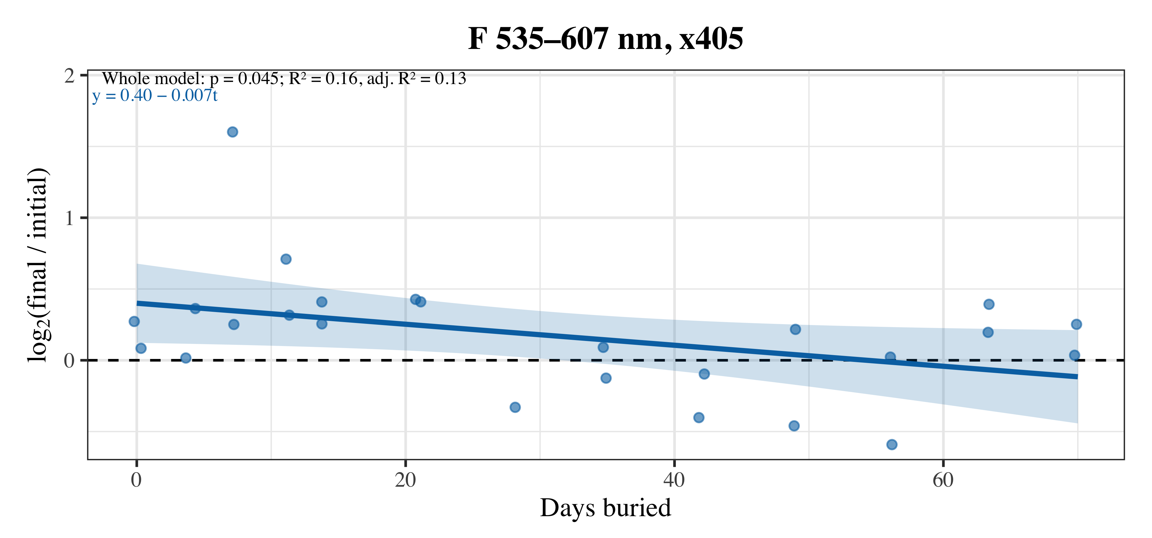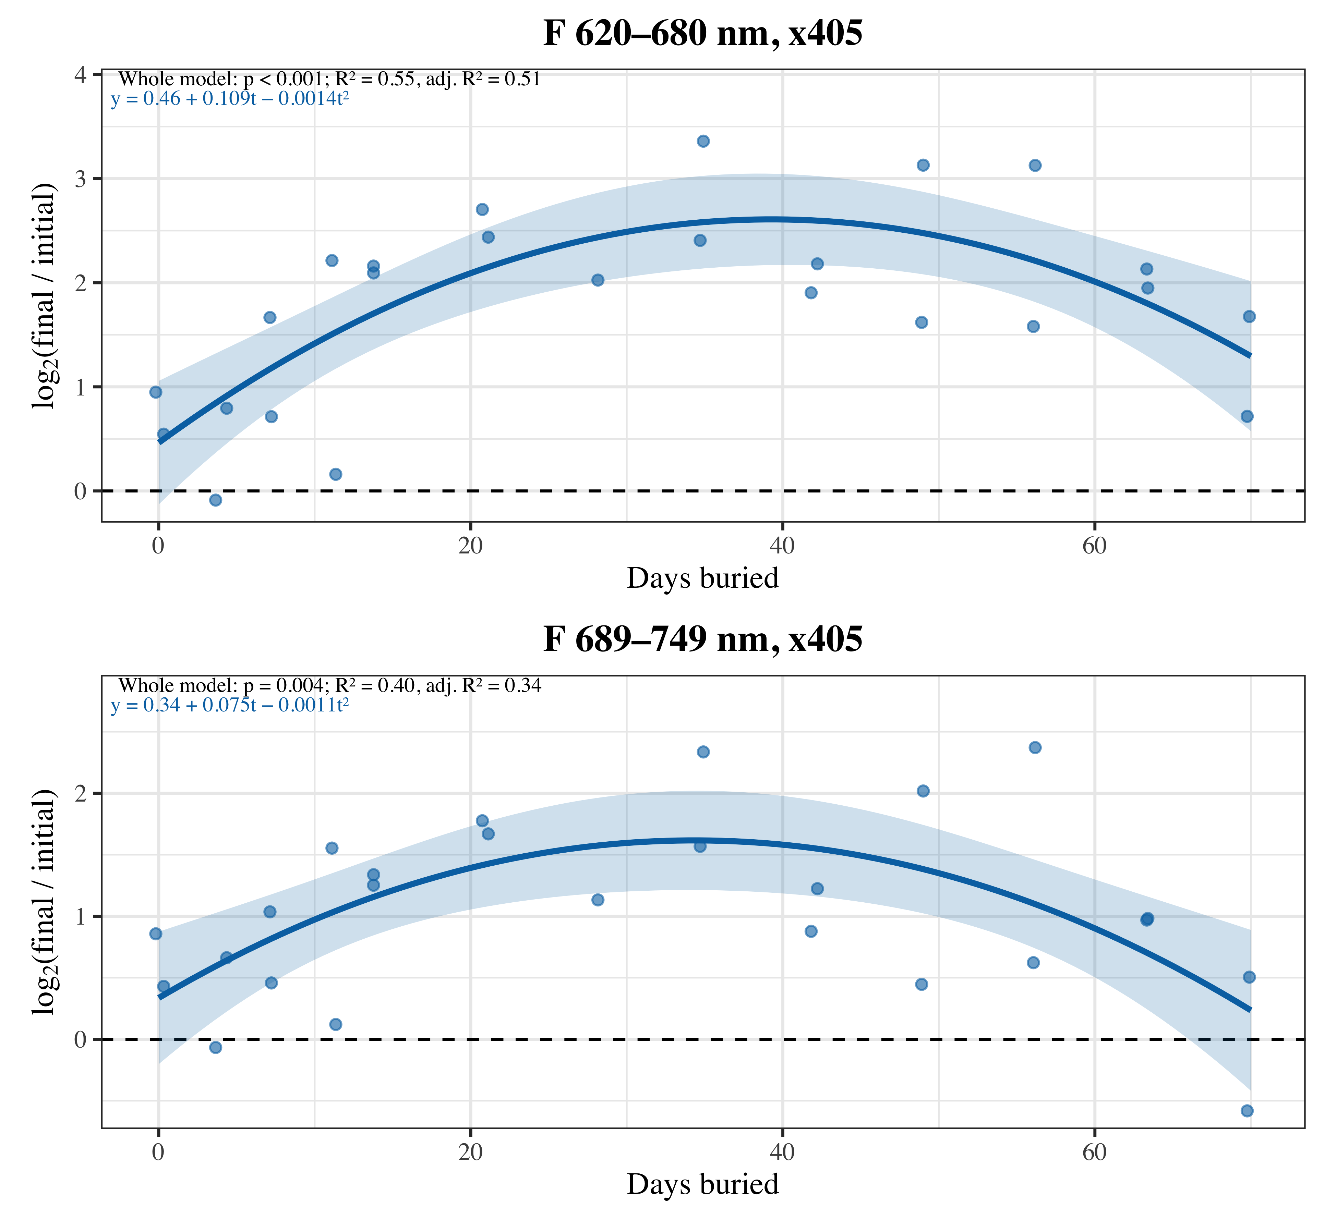
Figure 5: This figure depicts the significant relationships of the fluorescence ratio to initial state in different filters and the number of days that the leaf spent buried. The blue gradient next to the trend represent the 95% confidence interval and all the metrics associated with the model and the trends equation are given in the top left corner.

9 Fluorescence ratio Filter 620–680 / Filter 689–749 nm
Does the relative response of F 620–680 nm and F 689–749 nm change during burial?
- Linear: burial time: significant increase (F(1, 23) = 46.85, p < 0.001; slope = 0.014 per day); whole model: F(1, 23) = 46.85, p < 0.001; R² = 0.67 (adj. R² = 0.66); AIC = 2.8; n = 25.
- Polynomial (degree 2): burial time: significant (F(1, 22) = 64.44, p < 0.001); burial time²: significant (concave down) (F(1, 22) = 9.64, p = 0.005); whole model: F(2, 22) = 37.04, p < 0.001; R² = 0.77 (adj. R² = 0.75); AIC = −4.3; n = 25.
- Best model: polynomial. The quadratic term improves the fit (nested F(1, 22) = 9.64, p = 0.005); linear vs polynomial: AIC 2.8 vs −4.3, adj. R² 0.66 vs 0.75.

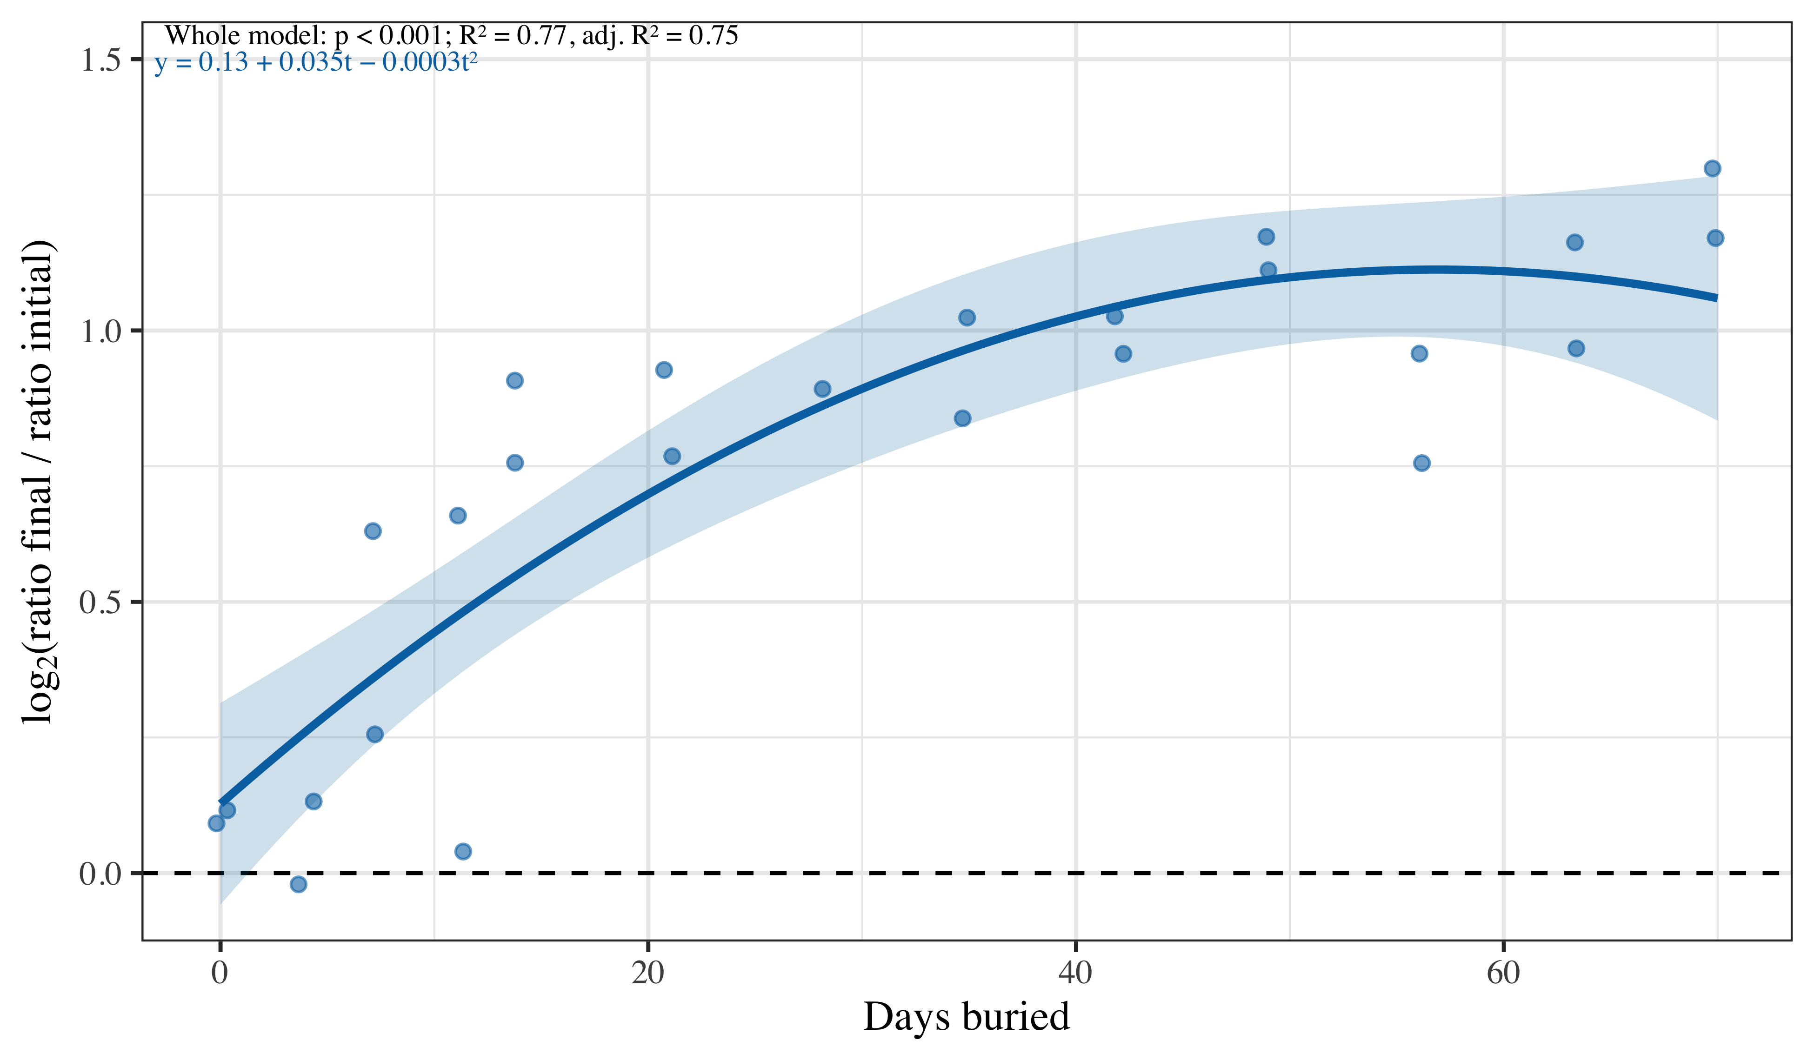
Figure 6: This figure depicts the significant relationships of log of the fluorescence ratio from Filter 590–710 and Filter 659–779 nm and the number of days that the leaf spent buried. The blue gradient next to the trend represent the 95% confidence interval and all the metrics associated with the model and the trends equation are given in the top left corner.

10 Reflectance change
Response: log₂(final / initial) for each reflectance channel (illumination inside the filter window); positive values = increase.

10.1 Filter 457–487 nm, excitation 470 nm
- Linear: burial time: significant increase (F(1, 23) = 30.54, p < 0.001; slope = 0.013 per day); whole model: F(1, 23) = 30.54, p < 0.001; R² = 0.57 (adj. R² = 0.55); AIC = 11.6; n = 25.
- Polynomial (degree 2): burial time: significant (F(1, 22) = 29.64, p < 0.001); burial time²: not significant (F(1, 22) = 0.32, p = 0.576); whole model: F(2, 22) = 14.98, p < 0.001; R² = 0.58 (adj. R² = 0.54); AIC = 13.2; n = 25.
- Best model: linear. The quadratic term does not significantly improve the fit (nested F(1, 22) = 0.32, p = 0.576); linear vs polynomial: AIC 11.6 vs 13.2, adj. R² 0.55 vs 0.54.

10.2 Filter 500–530 nm, excitation 525 nm
- Linear: burial time: significant increase (F(1, 23) = 8.91, p = 0.007; slope = 0.010 per day); whole model: F(1, 23) = 8.91, p = 0.007; R² = 0.28 (adj. R² = 0.25); AIC = 29.0; n = 25.
- Polynomial (degree 2): burial time: significant (F(1, 22) = 8.87, p = 0.007); burial time²: not significant (F(1, 22) = 0.90, p = 0.353); whole model: F(2, 22) = 4.88, p = 0.018; R² = 0.31 (adj. R² = 0.24); AIC = 30.0; n = 25.
- Best model: linear. The quadratic term does not significantly improve the fit (nested F(1, 22) = 0.90, p = 0.353); linear vs polynomial: AIC 29.0 vs 30.0, adj. R² 0.25 vs 0.24.

10.3 Filter 620–680 nm, excitation 635 nm
- Linear: burial time: significant increase (F(1, 23) = 34.21, p < 0.001; slope = 0.011 per day); whole model: F(1, 23) = 34.21, p < 0.001; R² = 0.60 (adj. R² = 0.58); AIC = −1.3; n = 25.
- Polynomial (degree 2): burial time: significant (F(1, 22) = 33.85, p < 0.001); burial time²: not significant (F(1, 22) = 0.75, p = 0.394); whole model: F(2, 22) = 17.30, p < 0.001; R² = 0.61 (adj. R² = 0.58); AIC = −0.2; n = 25.
- Best model: linear. The quadratic term does not significantly improve the fit (nested F(1, 22) = 0.75, p = 0.394); linear vs polynomial: AIC −1.3 vs −0.2, adj. R² 0.58 vs 0.58.
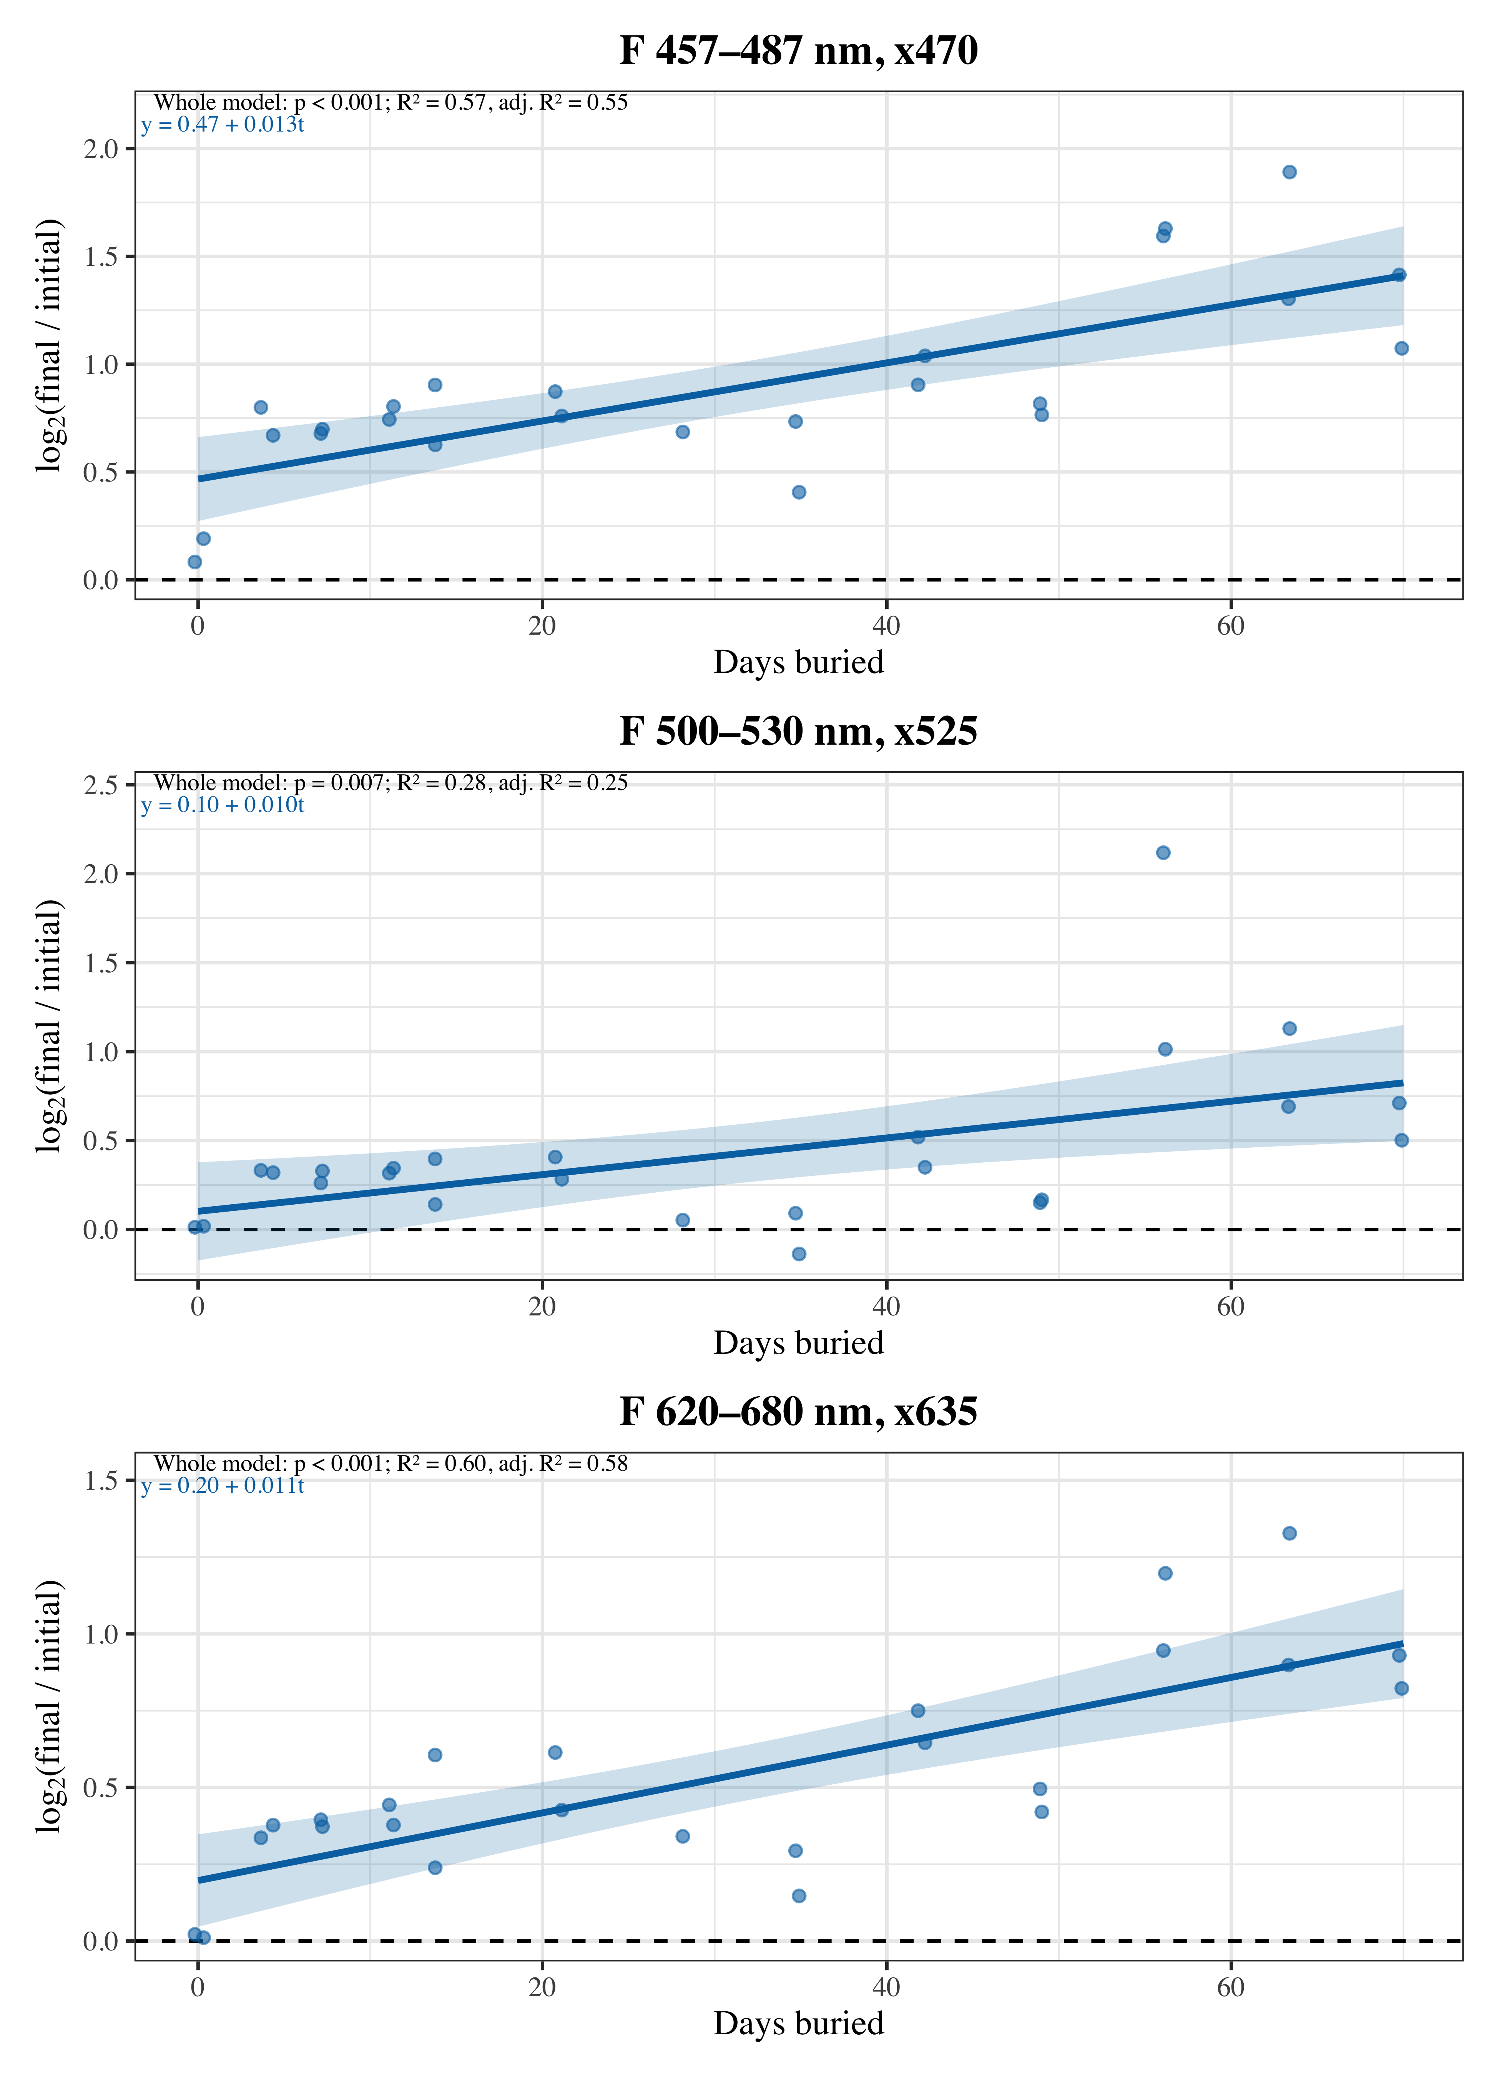
Figure 7: This figure depicts the significant relationships of the reflectance ratio to initial state in different filters and the number of days that the leaf spent buried. The blue gradient next to the trend represent the 95% confidence interval and all the metrics associated with the model and the trends equation are given in the top left corner.

11 Summary of all models
ANOVA, p-value of the whole model, R², adjusted R² and AIC. A tick marks the best model of each pair (see Statistical approach).
Response | Group | Model | Model p | R² | Adj. R² | AIC | Best
Surface change (%) | Betula | linear | 0.002 | 0.35 | 0.32 | 165.3 | ✓
Surface change (%) | Betula | poly. (2) | 0.008 | 0.36 | 0.30 | 167.0
F 535–607 nm, x405 | Betula | linear | 0.045 | 0.16 | 0.13 | 29.4 | ✓
F 535–607 nm, x405 | Betula | poly. (2) | 0.052 | 0.24 | 0.17 | 29.1
F 620–680 nm, x405 | Betula | linear | 0.057 | 0.15 | 0.11 | 67.7
F 620–680 nm, x405 | Betula | poly. (2) | <0.001 | 0.55 | 0.51 | 53.7 | ✓
F 689–749 nm, x405 | Betula | linear | 0.878 | 0.00 | −0.04 | 59.6
F 689–749 nm, x405 | Betula | poly. (2) | 0.004 | 0.40 | 0.34 | 48.9 | ✓
F 590–710 / F 659–779 nm ratio | Betula | linear | <0.001 | 0.67 | 0.66 | 2.8
F 590–710 / F 659–779 nm ratio | Betula | poly. (2) | <0.001 | 0.77 | 0.75 | −4.3 | ✓
F 457–487 nm, x470 | Betula | linear | <0.001 | 0.57 | 0.55 | 11.6 | ✓
F 457–487 nm, x470 | Betula | poly. (2) | <0.001 | 0.58 | 0.54 | 13.2
F 500–530 nm, x525 | Betula | linear | 0.007 | 0.28 | 0.25 | 29.0 | ✓
F 500–530 nm, x525 | Betula | poly. (2) | 0.018 | 0.31 | 0.24 | 30.0
F 620–680 nm, x635 | Betula | linear | <0.001 | 0.60 | 0.58 | −1.3 | ✓
F 620–680 nm, x635 | Betula | poly. (2) | <0.001 | 0.61 | 0.58 | −0.2
The polynomial model was preferred in 3 of 8 response × group comparisons; the linear model was sufficient in the other 5.

12 Spectra
Spectra acquired with the JETI spectrophotometer, shown between 625 and 850 nm for Betula in clay. Shorter wavelengths are removed by the filtering and are not shown or used in the normalisation. Within this range the spectra overlap the filters F 620–680 nm and F 689–749 nm (the bars above each figure; F 499–643 nm only reaches the lower edge of the range). Each line is one burial time. Three versions are shown: raw radiance, radiance normalised to the area under the curve (AUC) inside the window, and radiance divided by the total integration time. s

12.1 Raw radiance
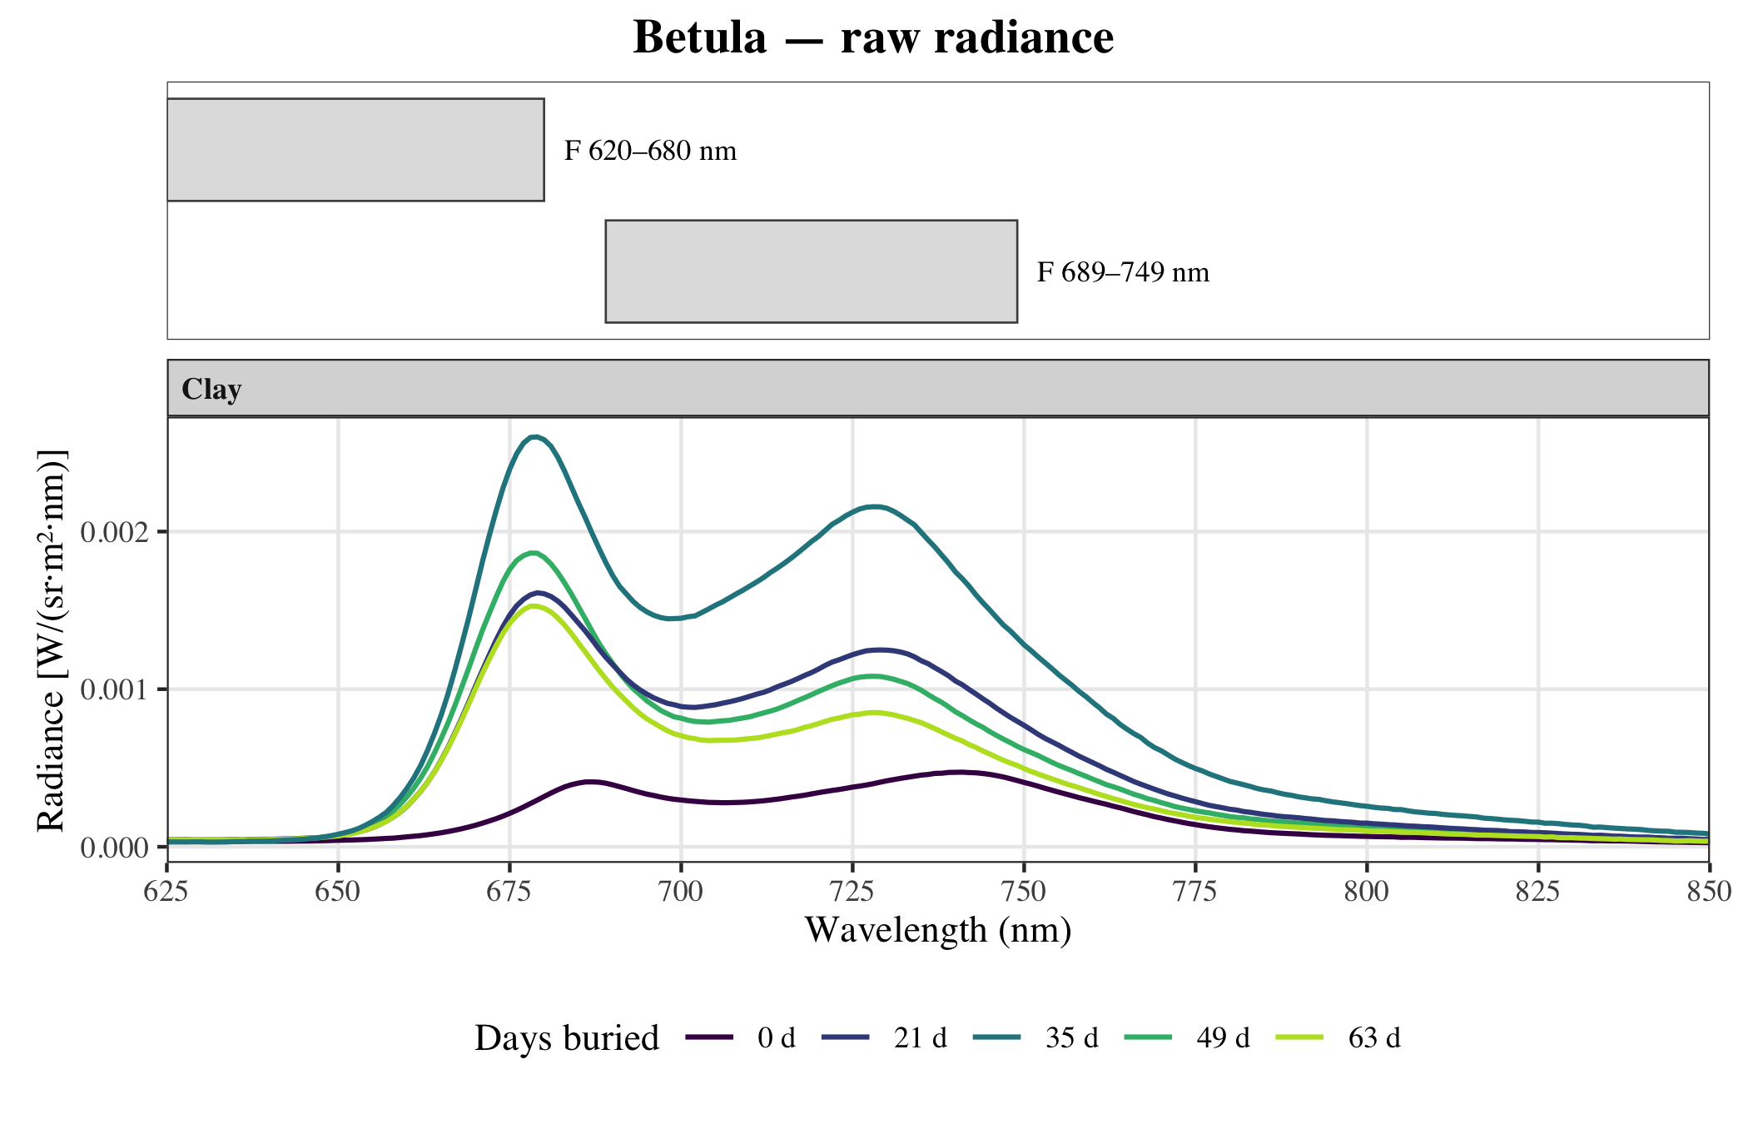
Figure 8: Raw radiance, 625–850 nm. The bars above give the filter windows (clipped to the plotted range).

12.2 Normalised to the area under the curve (AUC)
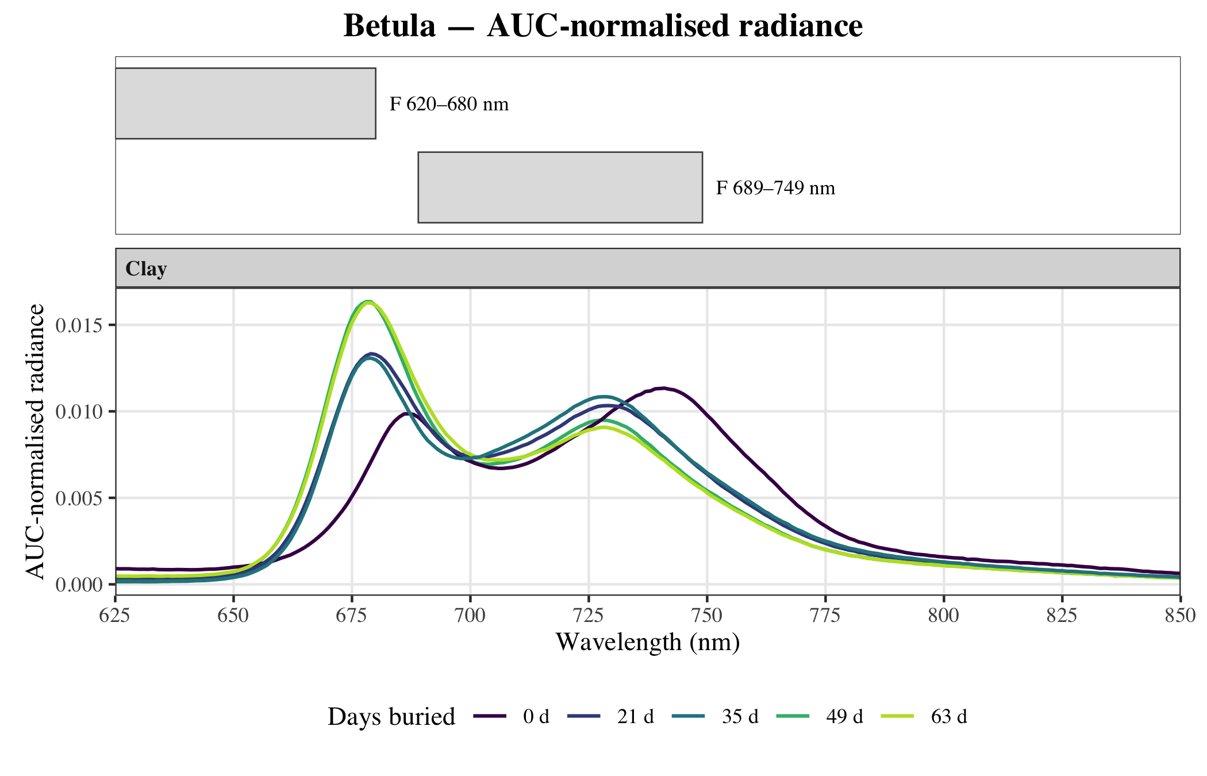
Figure 9: AUC -normalised radiance (area under the curve), 625–850 nm. The bars above give the filter windows (clipped to the plotted range).

12.3 Normalised by integration time
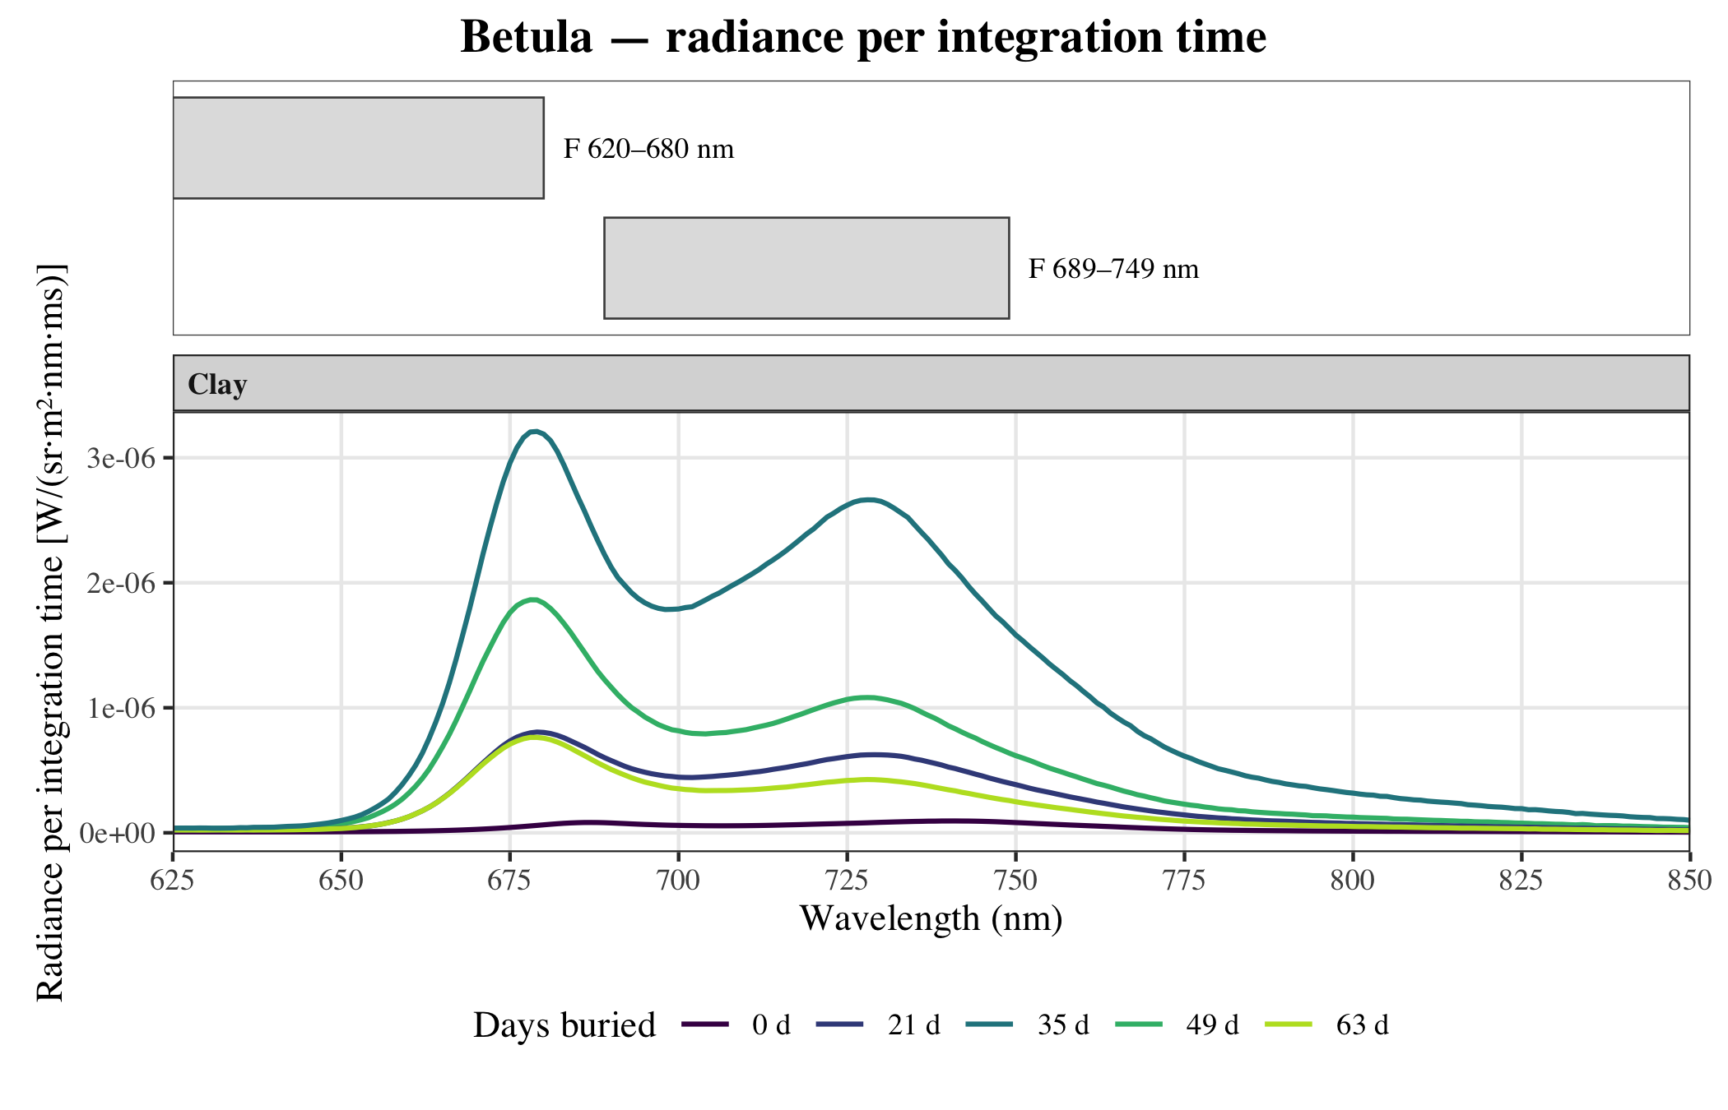
Figure 10: radiance per integration time, 625–850 nm. The bars above give the filter windows (clipped to the plotted range).

